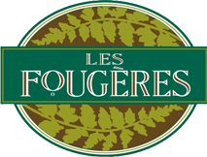
PRICE LIST

Item | Price
Scalloped Potatoes | $13.50
Flourless Chocolate Decadence | $20.95
Pizza | $13.95
Mushroom and Goat Cheese Quiche | $17.95
Alfredo Sauce | $7.95
Green Peppercorn Sauce | $8.95
Wild Mushroom Sauce | $8.95
Leek and Caper Sauce | $7.95
Tomato Basil Sauce | $7.95
Butter Chicken Sauce | $7.95
Green Thai Curry Sauce | $7.95
Soups | $12.50
Mushroom and Brie Tourte 9” | $20.95
Mushroom and Brie Tourte 5” | $7.95

